# SRIP’s cluster management competences; towards excellence

As a first step, this note reports on insights from literature and desk research concerning the human resource competences (skills, capabilities, education) that cluster management need. This information serves to design a framework to assess the gap between existing and needed capabilities and skills of staff of SRIP cluster organisations in Slovenia, as the main intermediary organisations involved in the S4 activities in Slovenia[1].

The actual competence needs assessment of the SRIPs management is the next step, which is mainly planned for November 2018. Depending on the extent and chosen method of assessment, reporting on the assessment results might be later than November 2018. The assessed competence gap will be the basis for the development of an implementation plan to fill the gap. The results of the three steps will be reported in a final document, of which this note could be seen as the first chapter.

1. Insights from desk research, designing a framework (this note);

1.1 Cluster management capabilities and assessment 2

1.2 Cluster management training 4

1.3 Clusters in Slovenia: SRIP partnerships 8

1.4 A framework to assess the gap in SRIP’s human resource capabilities for cluster management organisation 8

References and websites: 11

Annex 1 Three of 34 indicators of the ESCA labelling scheme: qualification, life-long-learning, and continuity of Human Resources of the Cluster Management Team; Source: ESCA (2013) 12

Annex 2 Best practice examples for general and specific training services to cluster management organisations (Source: Kergel et al. (2014). 14

1. Competence needs assessment (November 2018);
2. Plan for implementation and training (February 2019).

## 1 Insights from desk research, designing a framework

In order to come to a framework to assess the existing and needed competences, we first look for inspiration at methods to assess existing cluster management capabilities (1.1). Another source refers to assessing the needs for training and the content of existing trainings for cluster management organisations (1.2). In section 1.3 we discuss the case of SRIPs in Slovenia and come to a suggested framework to assess the needs (1.4).

### 1.1 Cluster management capabilities and assessment

The European Foundation for Quality Management (EFQM) has developed a general view on what good management is about: “Excellent Organisations achieve and sustain outstanding levels of performance that meet or exceed the expectations of all their stakeholders”[2]. For any public, private or intermediate organisation it is therefore key to realize who they are working for.

The literature on cluster management organisations emphasize that it is a special kind of organisation and that the management task are more complex. Christensen et al. (2012, p.13) address various dimensions of a cluster, namely: framework conditions, cluster participants and the cluster management organisation. On the latter they state: *“In order to facilitate collaboration between the cluster participants, there has to be a strong coordination body - a cluster management organisation. The quality of the cluster management is critical in order to initiate and support collaboration among companies and other relevant stakeholders of the cluster.”*

The European Commission launched the „European Cluster Excellence Initiative (ECEI)“ in 2009 in order to support cluster management organisations in their efforts to improve their work. Since the end of 2011, this „European Cluster Labelling Scheme” is operated by an independent private organisation VDI/VDE-IT under it’s brand „European Secretariat for Cluster Analysis (ESCA)“. According to the information on the assessment of the Gold label of ESCA: “The Quality Indicators focus on the cluster organisation hosting and operating the cluster management, not on the framework conditions or a cluster as such.” However, as they put it, “the item to be managed (the cluster as such), has to fulfil certain minimum requirements when considering the excellence of its management (certain minimum size, age, etc.).”



Kergel & Lämmer-Gamp (2015) explain how the ESCA indicators can be used to benchmark cluster organisations. Two dimensions of cluster organisation management are distinguished: financing (business model) of the management organisation and governance of the management organisation, which includes ‘human resource competence’ (see table 1)[3].

Table 1 Dimensions and assessment variables in ESCA benchmarking of cluster organisation management

| Dimensions of cluster organisation management | Examples of assessment variables |
| --- | --- |
| Financing of cluster organisation | Number of members, fees, chargeable services, annual budget, repartition of different financial sources (public / private), financial sustainability (taking into account the age of the cluster, inter alia), etc.. |
| Governance of cluster organisation | Definition of roles, implementation of a governing body, involvement of participants, number of cluster participants per employees of the cluster organisation, human resources competence and development, etc. |

*Source: adapted from European Secretariat for Cluster Analysis (*[*http://www.cluster-analysis.org/downloads/BenchmarkingPaperKergel_v4.pdf*](http://www.cluster-analysis.org/downloads/BenchmarkingPaperKergel_v4.pdf)*)*

Annex 1 provides the 3 questions/indicators used by ESCA concerning these competences. One of them is: *“What skills and experiences do the personnel involved in the cluster management have (evidence to be provided by relevant documentation on life/work track records and/or education)?”* (ESCA 2013). The answer and ‘evidence’ provided by the cluster manager (for all staff) to this question is scored by the ESCA evaluator, resulting into an indicator that can be benchmarked. The ECSA (2013) qualifications assessed for the gold label are:

* Tertiary level education
* Work experience in the private sector, excluding experience in cluster organisations or cluster management in particular
* Leadership and management skills
* Social skills including intercultural skills
* Communication skills
* Project management skills
* Language, skills in English
* Language, valuable skills in at least one foreign language (excluding English)
* Relevant sector and/or technical knowledge of > 3 years, due to education and/or work experience
* Cluster and policy related training.

Which answers lead to a high, low or sufficient score is not explained, but is up to the reviewing expert. The above list tells which human resource competences of cluster organisations are generally considered as reflecting what is needed. Since the need for capabilities and training may differs between different types of clusters, the standardized assessment methodology of ESCA is not sufficient to measure the gap between the skills and experiences that the personnel of the management organisation have and what is needed.

Schretlen et al. (2011) follow a less standardized, less ‘one-size-fits-all’ approach and emphasize the process of improving the cluster management competences in a tailor-made way which matches the specific situation. Their study focus on more general principles concerning ‘good governance’ and on how to find a suitable business model.

A conclusion of the 2nd European Cluster Policy Forum (2018) where labelling of cluster management standards was discussed, was that training for cluster management was at least equally important[4].

### 1.2 Cluster management training

In a study of approaches to improve the performance of cluster management organisations in Europe Kergel et al (2014, p.12) actually also conclude that a focus on the specific needs of cluster management organisations is more important than a standardized assessment of existing competencies. The following success factors have been identified for effective support services or training activities for cluster managers and staff:

* High demand orientation: the focus should directly be on what cluster management regards as a high need. This assures an active, motivated participation in the training and that the competences are directly applied to solve issues in the daily operation.
* Practice oriented: a practical rather than general, theoretical approach assures that the training fits the actual demands of the management and cluster at large.
* Training combined with experience exchange and networking: trainings should offer the possibility for exchanging experiences with other clusters and cluster managers. In this way the training also serves other networking activities and future opportunities for co-operation on other topics.
* Communication principles: the communication between the agency (that assesses training needs and implements the training) and the cluster management (staff) should be based on a sufficient level of trust, open-ness and commitment from both sides. E.g. cluster management should not feel afraid or embarrassed to discuss their competence gaps/needs.

The Cluster4Smart project (ERASMUS+ programme, 2017-2020)[5] aims to expand the knowledge of clusters’ managers of Europe through the development of an innovative, online training resource tool. The project has made use of 2 questionnaires to assess training needs of cluster management, one questionnaire for the cluster manager (and/or staff) and one for related stakeholders such as regional administrations, local authorities, regional development agencies, innovation and research facilities involved in cluster policy or cluster related project development.

It has a focus on cluster management abilities, knowledge, skills and competences that enable clusters to become the drivers of innovation, acceleration and collaboration, to foster cross-sectoral and cross-border technological development (Cluster 4.0) and industrial transformation, most notably ‘Industry 4.0’. The range of topics included for instance:

* Core work-related skills;
* Leadership;
* Internationalisation;
* Entrepreneurship and Innovation;
* Management;
* Digital skills;
* Language skills.

On these topics people were asked for several specific capacities to indicate the level of necessity and relevance (see table 2)

Table 2 Survey approach developed under the Cluster4Smart project

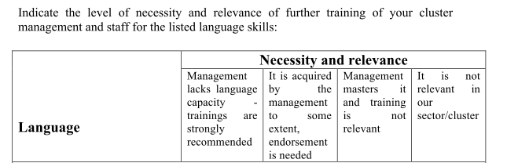

*Source: From survey used in the Cluster4Smart project*

The content of existing training for cluster management can also inform about which competences are regarded as essential. A first example draws on a presentation[6] by Véronique Renard (See European Cluster Policy Forum, 2018), a recently appointed Cluster Manager of a young cluster: ‘hospitality.brussels’ in Belgium, who gave feed-back from an experience with a training course she had followed from the organisation France Clusters. She first stated that ‘Knowing the eco-system & having the technical knowledge is not enough’, in order to develop efficiently the services & processes of the cluster organisation she felt the need to invest in cluster Management training, as a step towards cluster excellence. The topics or modules of the courses are provided in Figure 1 and 2: namely: management, business model; animation; innovation; communication; internationalisation.

Figure 1 Content of cluster management training from France Clusters



*Source: France Clusters training offer;* [*http://franceclusters.fr/en/*](http://franceclusters.fr/en/)

Figure 2 Modules of certified cluster management training



Source: European Cluster Policy Forum 2018: http://ec.europa.eu/growth/content/second-european-cluster-policy-forum-outcomes-future-cluster-labelling-cluster-mobility_en

The European Foundation for Cluster Excellence is another spin-off from the European Cluster Excellence Initiative (next to ESCA discussed above). Based in Barcelona, they provide various training courses. As inspiration the core content of one of them is shown in Table 2. The content of this training seems more theoretical, although between two weeks of in-class teaching the participants are asked to apply the knowledge at their own local clusters. The courses also address the need for knowledge about clusters among policy makers.

Table 2 Example of training content

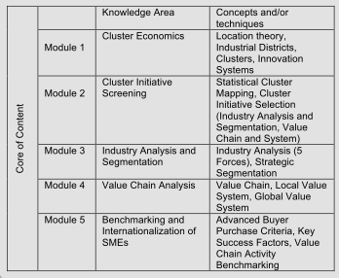

*Source: 2018/19 Cluster Excellence Management Training brochure, European Foundation for Cluster Excellence; http://www.clusterexcellence.org/*

### 1.3 Clusters in Slovenia: SRIP partnerships

In line with the definition by EFQM provided in 1.1, in the case of SRIP partnerships the management organisations work for all the ‘stake-holding’ partners, including the government that supports the SRIPs. The expectations of the government are mentioned in the agreements[7]:

* achievement of the objectives from the Action Plan (AP) for the concerning SRIP;
* Progress in development of joint R&D initiatives;
* Introduction of enabling technologies;
* Joint market activities;
* Success in internationalisation.

Furthermore, the call for a methodology to monitor SRIPs highlights the two aspects of finance/business model and governance, namely:

* the functioning and sustainability of the selected business model of individual strategic partnership (finance/business model);
* the organisational scheme and decision-making process (governance).

These two aspects correspond with those displayed in table 1.

As Wostner (2017) states in the case of Slovenia, more or less only funding for basic science comes from the national budget. Structural Funds from Cohesion policy are the main source for the SRIPs development. The current capabilities of the management organisations of the SRIPs concerning finance/business model (as mentioned in interviews with several SRIP managers) relates to the capability of reacting to national and European calls in the form of writing proposals. New elements such as developing services are mentioned as main challenges for the near future.

SRIPs were all created recently, but they are at different starting level, since in some fields there was an existing cooperation (clusters, Centres of Excellence, Competence Centres), while others have been created from scratch[8]. This is not only a complicating factor for monitoring and evaluation of the partnership activities and results, but also for assessing human resource competence needs. That is: it is likely that the needs will differ among SRIPs.

### 1.4 A framework to assess the gap in SRIP’s human resource capabilities for cluster management organisation

For the development of human resource competence in firms and sectors there are already existing institutions. The Competence Centre for Human Resource Development have developed an approach (Figure 3). A similar approach could be adapted to the development of cluster management competence. The approach is in line with the best practices described by Kergel (2014), see Annex 2, which start in the form of workshops, ranging from more general workshops with broader range of participants in a first step, to more specific ones for a more limited number of SRIPs managers in a second step. A session on November 14th on training needs for SRIP management could serve as kick-off, followed up with interviews and/or a short survey, in order to come to more specific next steps.

|  |
| --- |
| Figure 3 Competence Centre for Human Resources Development |
|  |

SRIP management and staff should discuss the need for training, also the range of partners in the concerning SRIP could contribute to this discussion. Some skill or knowledge gaps may be addressed from drawing on the capabilities of specific partners in the concerning SRIP: e.g. a company, or expert from a university, institute or government/agency. Also other SRIPs might be a good source to fill the gap. In case the concerning competences or expertise is lacking in Slovenia, international partners (e.g. partners in Vanguard initiatives or relations in Bavaria) may full-fill a role in ‘external’ training. The kind of need for training may also call for a search of new partnerships, and in case it concerns a long term or future need, it could be relevant to develop curricula for integration in the Slovenian education system, in order to train the cluster and S4 managers of the future.

Also the framework that is used to forecast competences requirements for companies (figure 4), can be applied to the competence requirements of the SRIP management organisations (Figure 5). The current characteristics and the future challenges of SRIPs are defining the competence requirements and need for training. Some training needs may exist for all SRIPs, but there will also be more specific and individual needs. Both these needs will have to be identified and ‘discovered’.

Figure 4 Framework used to forcast competence requirements in general for S4 and industrial transformation



*Source: Slide from presentation by Gorazd Jenko on Human Resources for S4 and Industrial transformation at OECD workshop, Brussels 15-16 May 2018*

Figure 5 Adaptation to Competence requirements for SRIP management



Future challenges for cluster management not only derive from technological change, but especially from the institutional and organisation changes that are considered relevant. From the mentioned examples and literature addressed in this section, as well as the SRIP agreements, we can list as broad main categories of competence needs (for either more basic or very specific training): Management; Marketing & communication; Business model; Collaboration for innovation; Future challenges.

|  |  |  |  |  |  |
| --- | --- | --- | --- | --- | --- |
|  | Cluster Management | Cluster Marketing & communication | Cluster Business model | Cluster Collaboration for innovation | Future cluster challenges |
| SRIPx |  |  |  |  |  |
| SRIPy |  |  |  |  |  |
| SRIPz |  |  |  |  |  |

## References and websites:

Christensen, T.A., Lämmer Gamp, T., and Meier zu Köcker, G. (2012). Let’s make a perferct cluster policy and cluster programme - Smart recommendations for policy makers. <https://www.cluster-analysis.org/downloads/Clusters_web_singlepage_06092012.pdf>

European Cluster Excellence Initiative (ECEI) (2013) “The Quality Label for Cluster Organisations (Cluster Management Excellence Label GOLD – Proven for Cluster Excellence) Criteria, Processes, Framework of Implementation.

European Cluster Policy Forum (2018; forthcoming). Output paper of second meeting.

European Foundation of Quality Management: <http://www.efqm.org/efqm-model/fundamental-concepts>

European Foundation for Cluster Excellence: http://www.clusterexcellence.org/

ESCA (2013) The Quality Label for Cluster Organisations (Cluster Management Excellence Label GOLD – Proven for Cluster Excellence) Criteria, Processes, Framework of Implementation.

France Clusters: http://franceclusters.fr/en/

European Secretariat for Cluster Analysis (ESCA): https://www.cluster-analysis.org/

Ketels, C., Lindqvist, G., and Sölvell, Ö. (2012). Strengthening Clusters and Competitiveness in Europe - The role of cluster organisations.

Kergel H. & T. Lämmer-Gamp (2015) Benchmarking of Cluster Management Organizations. European Secretariat for Cluster Analysis (ESCA), Berlin.

Kergel, H., Köcker, G., & Nerger, M. (2014). New approaches to improve the performance of cluster management organisations in Europe. European Secretariat for Cluster Analysis (ESCA), Berlin.

Schretlen, J.-H., Dervojeda, K., Jansen, W., and Schaffmeister, B. (2011). Uncovering excellence in cluster management.

Wostner, P. (2017). From Projects to Transformations: Why Do Only Some Countries and Regions Advance? The Case of the Slovenian S4. European Structural & Investment Funds Journal, 5(1).

## Annex 1 Three of 34 indicators of the ESCA labelling scheme: qualification, life-long-learning, and continuity of Human Resources of the Cluster Management Team; Source: ESCA (2013)

**Indicator 2.2.2: Qualification of the Cluster Management Team**

Question

* What skills and experiences do the personnel involved in the cluster management have (evidence to be provided by relevant documentation on life/work track records and/or education)?

Additional Information

The assessment shall be done for each person in the cluster management team and the scores shall be weighted according to the % of FTE each person contributes to the cluster management. Back-office personnel, like secretary, accountant, etc. shall only be included in the assessment if relevant for cluster management activities (to be decided and argued by the cluster manager). Pure administrative personnel (book-keeping, personnel managing the facility of the cluster organisation, etc.) shall not be included in this assessment.

Qualification assessed:

* Tertiary level education
* Work experience in the private sector, excluding experience in cluster organisations or cluster management in particular
* Leadership and management skills
* Social skills including intercultural skills
* Communication skills
* Project management skills
* Language, skills in English
* Language, valuable skills in at least one foreign language (excluding English)
* Relevant sector and/or technical knowledge of > 3 years, due to education and/or work experience
* Cluster and policy related training.

Possible documentation: certificates, CV, life history, …

**Indicator 2.2.3: Life Long Learning Aspects for the Cluster Management Team**

Questions

* Are there programmes and budgets for continuous training (for cluster development as well as more generalised management and communication issues) of the cluster management team planned and are such training activities carried out in a significant manner?
* How many documented training days / FTE were realized in the last 12 months OR the 12 months before?
* Is there a regular training programme for the cluster management staff in place?
* Is there an adequate budget planned in a documented way for training of the cluster management staff?

Additional Information

* “Adequate budget” means that the cluster management annual budget foresees resources (personnel costs, external costs, etc.) for training of the cluster management team.
* Back-office personnel, like secretary, accountant, etc. shall only be included in the assessment if relevant for cluster management activities (to be decided and argued by the cluster manager).

**Indicator 2.2.4: Stability and Continuity of Human Resources of the Cluster Management Team**

Questions

* How many persons involved in key activities of the cluster management have left the cluster
* management team within the last 24 months?
* Were team members leaving replaced directly (within 3 months)?
* Did the operative cluster manager leave the cluster management team?
* Are there job descriptions for the key personnel available in written format?

## Annex 2 Best practice examples for general and specific training services to cluster management organisations (Source: Kergel et al. (2014).

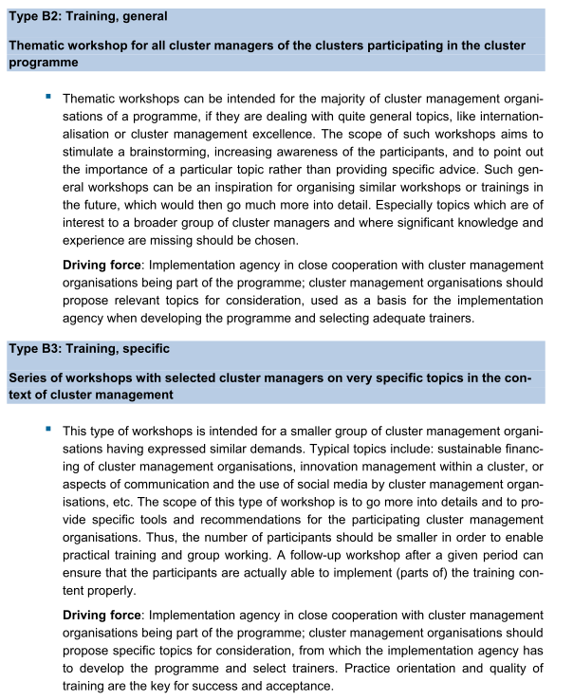

Source: Kergel et al. (2014, p.14)

1. The framework, assessment and training may also be applied at a later stage to other intermediary organisations and institutions in the S4 strategy.
2. http://www.efqm.org/efqm-model/fundamental-concepts
3. The two aspects also are in line with the expectations of the Slovenian government towards SRIPs (section 1.3)
4. http://ec.europa.eu/growth/content/second-european-cluster-policy-forum-outcomes-future-cluster-labelling-cluster-mobility_en
5. http://ec.europa.eu/growth/content/second-european-cluster-policy-forum-outcomes-future-cluster-labelling-cluster-mobility_en
6. https://ec.europa.eu/docsroom/documents/31488
7. As formulated in the draft Methodology for monitoring and evaluation of Strategic Partnerships
8. As stated in the draft methodology to monitor and evaluate SRIPs of September 2018