**We are getting closer to the grand finale!**

**[AMULET H2020](https://www.linkedin.com/company/amulet-h2020/)**

There are only 2 months left of the AMULET project!

It was nearly three years of hard work made by project partners to ensure different activities for the entire AMULET community. We are getting closer to achieving our goal which is to create new value chains by supporting the penetration of advanced lightweight materials in various fields through inter-regional and cross-sectoral knowledge exchange in four sectors: automotive, aerospace&aeronautics, energy and building.

All AMULET partners would like to thank you for your interest in our project, your support of each activity, and your active involvement.

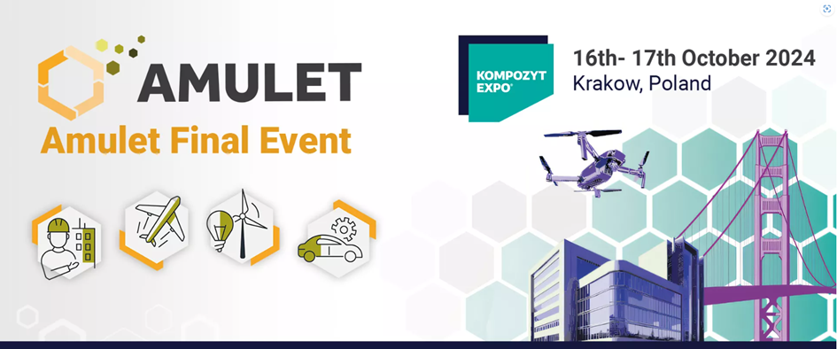

The Advanced Materials & Manufacturing United for LightwEighT project is fast approaching its finale. With only five more months to go, it is time to announce that we have begun preparations for our AMULET Final Event.

**It will occur on 16-17 October 2024 during the 13th International Trade Fair for Composite Materials, Technologies and Products** [**KOMPOZYT-EXPO®**](https://kompozyt-expo.pl/) **in Krakow, Poland.**

The AMULET project aimed to harness the innovation potential of SMEs that were creating new value chains by supporting the penetration of advanced lightweight materials in the industry. AMULET focused on three advanced materials: light metal alloys, ceramic matrix composites, polymer-based composites and their applications in four sectors: building, aerospace&aeronautics, energy and automotive. During the final event, we will present the joint work on advanced lightweight materials and the results that we achieved.

**Meet us at the booth D44a!**

You will have a unique opportunity to:

* Meet with project partners and establish business contacts
* Get to know the assumptions of the project and what we have managed to achieve during its implementation
* Explore the innovative solutions of our 15 finalists - consortiums composed of 34 SMEs from 17 EU countries.

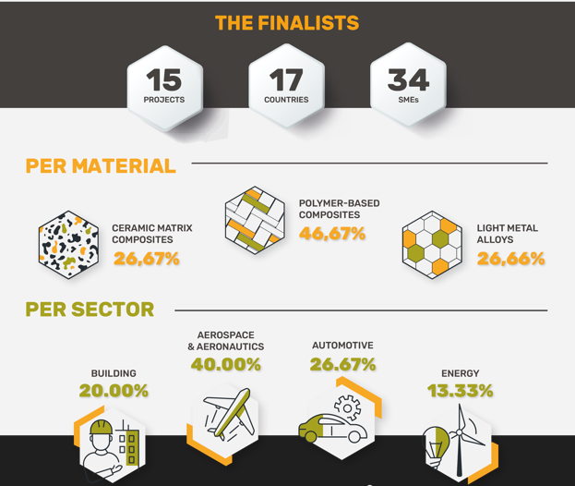

During the Kompozyt Expo fair, the European Lightweight Cluster Alliance ELCA General Assembly meeting will be held. This international network brings together clusters, R+D units and industry organizations. The network aims to create a partnership on a European scale for the development and application of polymer plastics (lightweight structures) by coordinating cooperation between different entities.

All those who visit the AMULET project booth will have a possibility to meet all consortium partners, learn about the assumptions and objectives of the project, and, above all, meet our 15 finalists - various consortia from all over Europe - who have successfully passed all stages and completed their projects with the AMULET cascade funding programme support.

Stay tuned! Visit our website under the Final Event tab, where we will keep all the information up to date:

[Amulet Final Event - AMULET (](https://amulet-h2020.eu/amulet-final-event/)[amulet-h2020.eu](http://amulet-h2020.eu/)[)](https://amulet-h2020.eu/amulet-final-event/)

If you want to join us registration is required!

AMULET consortium partners,

